ART101 Timeline Assignment

Step 1: Download the Timeline Template (PowerPoint) located in Unit 1.
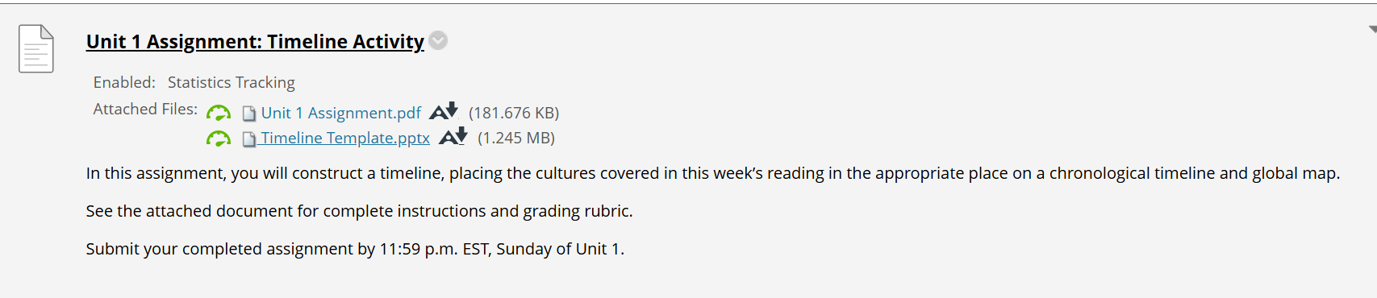

Step 2: Once you have downloaded the PowerPoint template, select “enable editing” at the top of the screen.
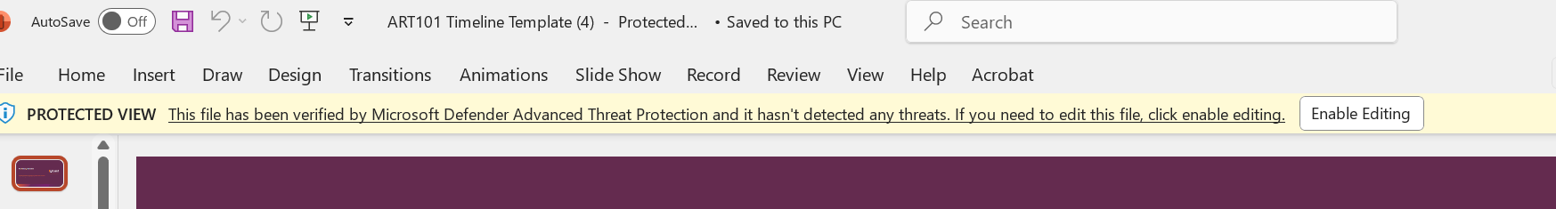

Each week, you will explore a new time period and art styles from each of those time periods.
- Unit 1 explores Prehistoric Europe and Ancient Near East artwork.
- Unit 2 explores Ancient Egypt and Ancient Aegean artwork.
- Unit 3 explores Ancient Greek and Etruscan artwork.
- Unit 4 explores artwork from the Roman Empire and Late Antiquity.
- Unit 5 explores artwork from Byzantium and the Islamic World.
- Unit 6 explores artwork from Medieval Europe.
- Unit 7 explores artwork from South and Southeast Asia, China, Korea, and Japan.
- Unit 8 explores Pre-Colonial Americas and African art.

Step 3 (Unit 1 submission): Locate one image of a piece of artwork from the Prehistoric Europe and the Ancient Near East time periods.

Step 4: Insert those images onto the Timeline PowerPoint template on slide # 2.
- HINT: An image for Prehistoric Europe is included on the template to help you get started.
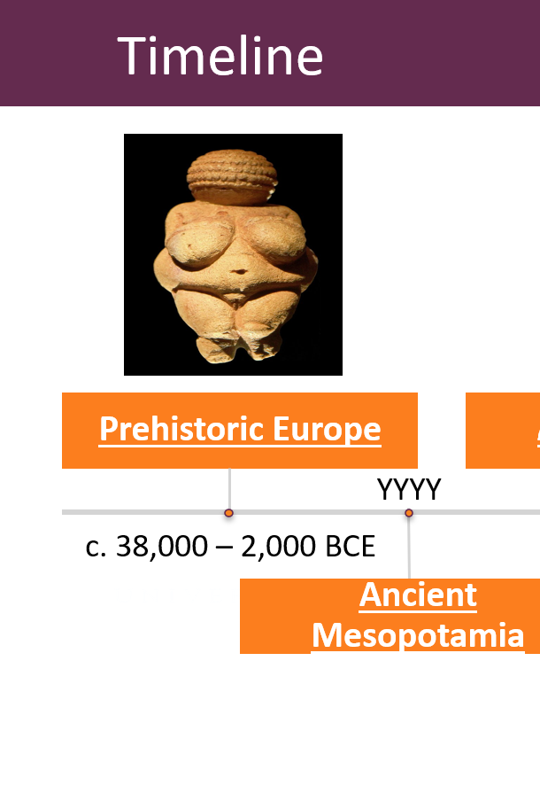
- You will need to locate and add an image for Ancient Mesopotamia (often referred to as Ancient Near East).

Step 5: Once you have pasted images onto the timeline for Prehistoric Europe and Ancient Near East, you will need to enter the corresponding date ranges.
- HINT: The date ranges for Prehistoric Europe have already been added (38,000 – 2,000 BCE) for you, so you will follow this same format and enter the date ranges for Ancient Near East on slide # 2.

Step 6: Once you are done adding your images and dates to slide # 2, you will jump to slide # 5. On this slide, you need to move the red star (located on the top of the slide) to the correct geographical location on the map.
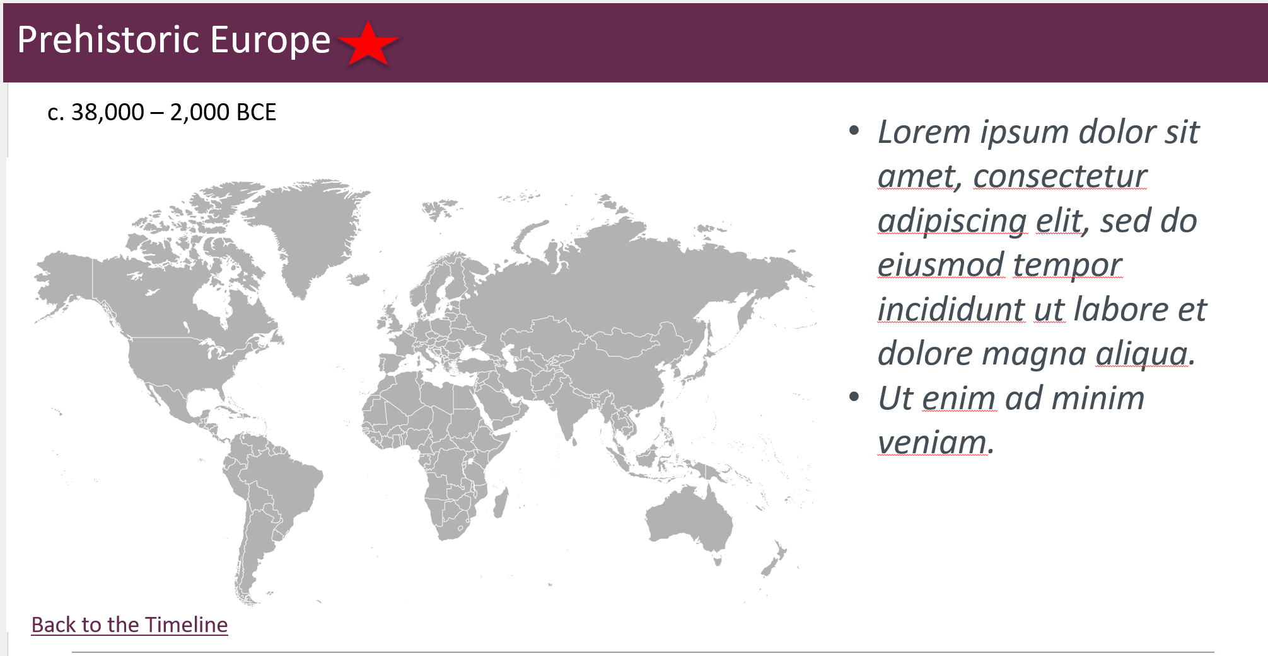

Step 7: Once you have moved the start onto the map, you need to edit the text located on the right-hand side of the same slide. This text serves as a placeholder, and you are tasked with replacing it.
You will replace this text with three sentences (in your own words) describing three ‘big-picture’ ideas, or significant traits of ancient near eastern art.

Step 8: You will repeat steps 6 and 7 on the next slide (# 6), filling in the Ancient Near East information.

Once you have completed these steps, you’re ready to submit for Unit 1!
In Unit 2, you will repeat the same steps for Ancient Egypt and Ancient Aegean artwork.
You will follow this same process for each time period throughout the term, and you will submit the final (completed) version of your timeline in Unit 8.

