FYE120: WEEK 6 ASSIGNMENT STUDY GUIDE

STEP 1: Begin by writing a short, professional biography about yourself. Use the grid below to organize your thoughts.

Name (Professional name; no nicknames)
Academic Background (list your major, areas of academic interest, and college are you attending)
Career Interests (Is there a specific profession you are working toward or field of work that interests you?)
Professional Goals (Is there a job title you wish to achieve one day? Is there a project you want to work on? Is there a business you would like to start?
Skills from Past Work Experience (e.g. Perhaps you worked in a service industry and developed excellent customer service skills)
Closing (Prepare a closing statement that thanks the audience and is professional in tone)

STEP 2: Open a MS Word document and, using the notes above, write your professional biography using complete sentences.

STEP 3: Navigate to the bottom of the Week 6 Assignment instructions page and view the “Post University Kaltura Student Reference Center” resource. This will help prepare you to record using Kaltura.

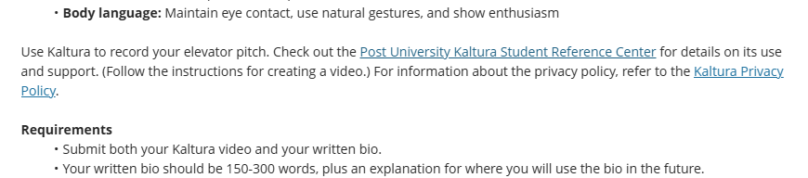

STEP 4: Using the professional biography you wrote, record yourself presenting this biography. Focus on speaking slowly and clearly. It is important that you present yourself professionally, so consider your attire and background when recording.

STEP 5: Use the “Submission” field at the bottom of the of the Week 6 Assignment instructions page and submit two documents: 1.) Your MS Word document with your written professional biography, and 2.) Your Kaltura video recording.

Remember: Assignments are typically due on Sunday evenings at 11:59 PM EST

